** ** 

Implementation Modalities of the Post 2015 Development Agenda:

Consultations with National and Sub-national Stakeholders in Tajikistan

Analysis and Recommendations

Dushanbe, July 2014

**Acknowledgement**

This report was prepared by Shahrbanou Tadjbakhsh, Consultant of the UN Country Team in Tajikistan, with the help of Yusuf Kurbonkhojaev of UNICEF Tajikistan on the basis of notes from rapporteurs and moderators of the 2 day national consultation on localizing the Post-2015 Development Agenda in Tajikistan organized by the Ministry of Economic Development and Trade and the UN in Tajikistan on July 17-19th, 2014.

Acknowledgement for the finalization of the Report and the organization of the Consultations go to Mr. Alexander Zuev (UN RC), Ms. Laylee Moshiri, UNICEF Representative and Mr. Umed Davlatzod, the Deputy Minister of Economic Development and Trade and his staff.

**Table of Contents**

**Post-development agenda in Tajikistan 4**

**Alignment with Government’s national development strategy 4**

**From What to How: National and Sub-National Consultations on Localizing the Development Agenda and Modalities for Implementation 5**

**Methodology and Participants 6**

**Communication 7**

**Stakeholder Mapping 10**

**Defining local bottlenecks and opportunities for implementing the post-2015 development agenda and new NDS 13**

**Ownership (Localization of the Development Agenda) 17**

**Participation of Stakeholders at the local and national levels 19**

**Partnership between stakeholders 2121**

**Capacities 23**

**Planning and Budgeting 25**

**Monitoring and Evaluation 27**

**Conclusion 29**

**The Post-Development Agenda in Tajikistan**

In 2013, Tajikistan was chosen as one of the sites of the initial round of global conversations launched by the United Nations (UN) Development Group, to gauge perceptions on the post-2015 Development Agenda and priorities at the global and national levels. The result, a four month consultative process organized by the UN Country Team with the help of the Ministry of Economic Development and Trade, offered the opportunity for Tajikistan not only to contribute to the dialogue, but at the same time identify areas of priorities for the country’s own development agenda beyond 2015. While the current Tajikistan National Development Strategy (NDS) and its time frame are aligned with the MDGs until the end of 2015, the post-MDG consultations became an important contribution to the planning of the subsequent NDS of the Government and its vision beyond 2015. The results, together with that of other countries, informed the report of the UN Secretary General on the Millennium Development Goals (MDGs) and the post-2015 agenda: *A Life of Dignity for All*.

The consultations in Tajikistan, which took place from February 2013 to May 2013, involved roundtable discussions, the circulation of questionnaires, and the use of on-line surveys and the social media. A total of 1050 individuals representing different stakeholder groups and from different parts of the country actively took part in the consultations and offered their views and recommendations for shaping the future they desired for Tajikistan. Many more were informed that such a process was taking place in the country. Partners in this process included:

* The Ministry of Economic Development and Trade
* The Parliament (Majlisi Namoyandagon)
* The Institute of Strategic Studies
* The National Association of Managers
* The National Association of Non-Government Organization of Tajikistan
* Youth organizations, including Society and Us, Tomiris, etc.
* The Scientific Research Institute of the Ministry of Labor and Social Protection.

Among the priorities areas emerging for the Post-2015 development agenda for Tajikistan, the following feature prominently:

1. **Education** as a priority in itself and as a precondition to achieving other development goals, including access, quality, financing and governance;
2. **Health** including access to quality health care services;
3. **Employment** including the need for creating conditions to improve the labor market, create jobs and regulate labor migration;
4. **Eradication of inequalities** by gender, age and disability status;
5. **Governance**, in terms of improving the quality of public administration, curbing corruption and increasing civic engagement;
6. **Food security and nutrition;**
7. **Social protection**, social benefits and services; and,
8. **The need for conflict prevention.**

**Alignment with the Government’s National Development Strategy**

The grand development objectives of the Government of Tajikistan are threefold: To reach energy independence; to take the republic out of communication isolation, and to ensure food security. To reach these objectives, the Government has elaborated a long term National Development Strategy (NDS) until 2015. The NDS itself consists of three year medium term Strategic Plans for the Living Standards Improvement Strategy (LSIS) of the Republic of Tajikistan, with three so far elaborated (2007-2009), 2010-2012 and 2013-2015.

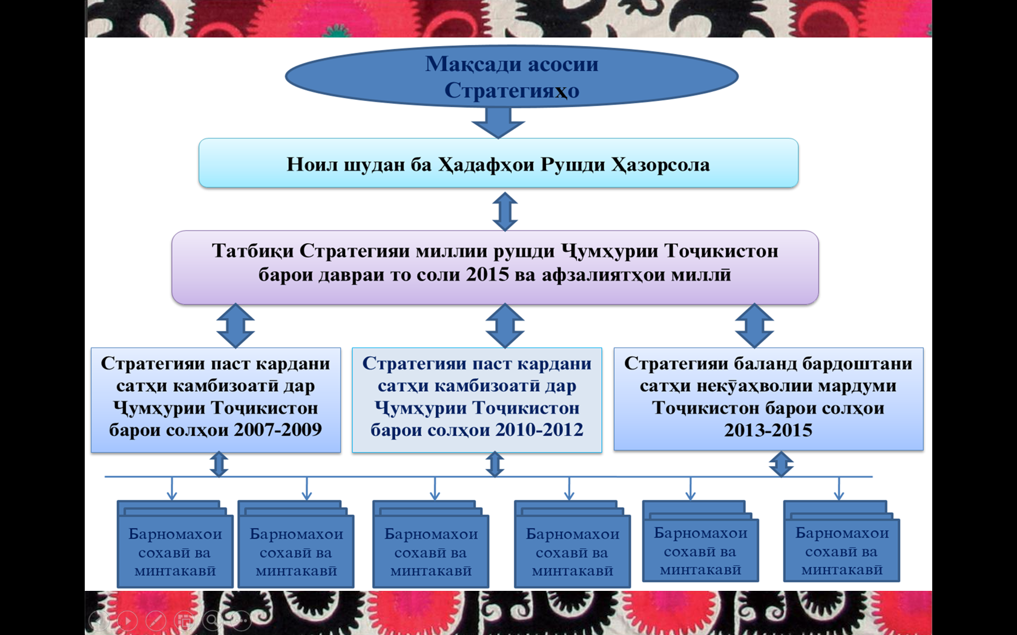

In the long term, the NDS and its Medium Term LSIS, the 7 primary MDGs and the 8 priority areas identified during the Phase I of the Post-Development Consultations all find echo. The LSIS (2013-2015) also clearly identifies some means of implementation: reaching the objectives, it stipulates, will be driven by a number of concrete strategies: Reform of state administration, boosting macro-economic growth, improving the environment for investment, consultation with and engagement of the private sector, and the growht of human resources. The Strategies also outline the responsible bodies, the execution modalities, indicators for monitoring as well as the means of financing.

In its quest to prepare for the next phase of the NDS, the Government of Tajikistan aligned forces with the UN Country Team in Tajikistan to organize the first phase of consultations on the Post-2015 Development Agenda as well as on the second phase consultation on the Localization of the Post-Development Agenda and Means of Implementation. The results of the two consultations, both on the content and the means of implementation, will help in the elaboration of the long term strategy until 2030 as well as the Medium Term Sustainable Development Plan for 2016-2020.

**From What to How : National and Sub-National Consultations on Localizing the Development Agenda and Modalities for Implementation**

During the consultations at the global level (2013-2014), it became clear that the achievement of the critical Post-2015 Development Agenda, much like the implementation of the MDGs, would require ownership, grassroots support and community buy in, local accountability, viability of local institutions, and sustainability of gains. Any new development agenda will only impact people’s lives if successfully implemented at the local level.

While the Open Working Group (OWG) on the Post-2015 Development Agenda continued its deliberations to identify the final set of focus areas, the targets for each and the overall timeframe, implementation modality of the eventual goals were also being considered. To this aim, the UN launched a second round of consultations to stimulate inclusive dialogue on the means of achieving the post-2015 development agenda at the local level, identify solutions and enhance the importance of the local dimension of development.

Tajikistan was chosen as one of the countries to launch the second phase of consultations. To this aim, the UN Country Team, in collaboration with the Ministry of Economic Development and Trade organized a consultation process with stakeholders at that sub-national and national levels to discuss the various modalities of implementing the future global development framework and the eventual post 2015 National Development Strategy of Tajikistan.

The objectives of the 2 day consultation workshop, organized in Dushanbe on 17-18 July 2014 were:

* To identify and build consensus around the possible implementation modalities and means of delivery of the goals of post-2015 Development Agenda in Tajikistan and at the global level
* To contribute with ideas and recommendations to benefit the Government at the national and sub-national local levels in identifying goals and improving implementation modalities of the next National Development Strategy beyond 2015. The dialogue on localization of the post-2015 development Agenda is expected to encourage 1) the different levels of government to work together to improve service delivery and, 2) to engage citizens and mobilizing them to participate in and drive their development process at the local level.

**Methodology and Participants**

The 2 day consultative workshop emphasized interaction and discussions to maximize the possibilities for exchanges.

* The first day was dedicated to consultations with approximately 80 stakeholders from the sub-national level (representative of local governments (Provincial and District level), Civil Society Organizations in regions, private sector representatives from different parts of Tajikistan).
* The second day brought together the sub-national participants of the first day together with representatives of national structures based in Dushanbe (i.e. representatives from line ministries, parliamentarians, media, civil society and the private sector). A participatory method was used for all groups in plenary mode in order to build consensus on the means of implementation identified during the first day between national and sub-national partners.

Representatives of the following structures at the national and sub-national (local) levels were invited to the workshop in Dushanbe:

1. Parliament/President’s Office
2. Line Ministries and state committees
3. Local (viloyat and district) governments
4. Civil society organizations
5. Private sector
6. Media
7. Academia
8. UN Country Team
9. International community, including bilateral donors

**Communication**

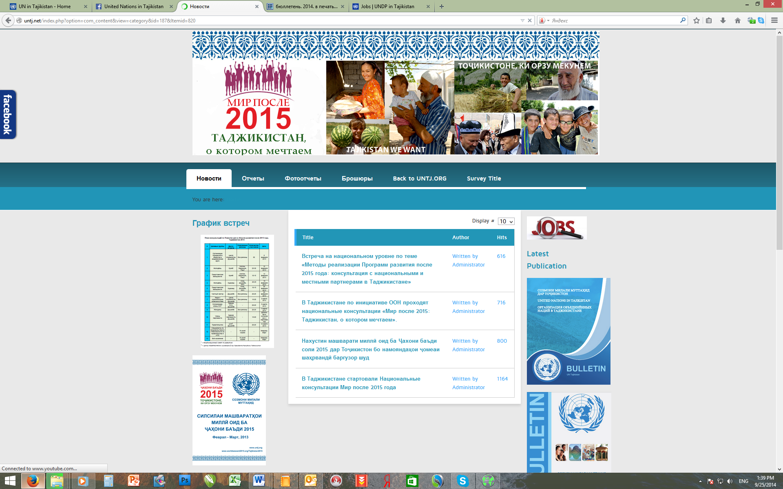A webpage dedicated to the National Consultation processes in Tajikistan was created at the UN Tajikistan website and served as an information hub for the issues, related to Post MDGs process. The webpage is available through the following link: <http://www.untj.org/talk/>

Information about the scheduled meetings with different groups of the population, leaflets and other information materials on this topic, results of the meetings, reports and links to the external sources were posted on the page.

UN Communication Group members used the Facebook Social Network to promote the ideas of people’s participation and raising their voices.

Online event was created on Facebook Social Network to involve different groups of population, inform them and hear their ideas about the future they want.

More than 1,000 people were engages with information spreading activities and discussions through UN in Tajikistan Facebook page and an official online event created for this purpose. This round of the e-consultations was mainly having information character.

[www.facebook.com/events/411447932329091/?ref=2&ref_dashboard_filter=past](http://www.facebook.com/events/411447932329091/?ref=2&ref_dashboard_filter=past)

Global leaflet developed by UNDP was adapted and published in Tajikistan to spread the information about the continuation of the process. The leaflet is available online on the UN web-page devoted to the Post MDGs process. Special edition of the UN Bulletin devoted to the Post MDGs process which was published upon conduction of the first round of the national consultations. This bulleting was disseminated among participants of the second round of consultations along with other leaflets and information materials.

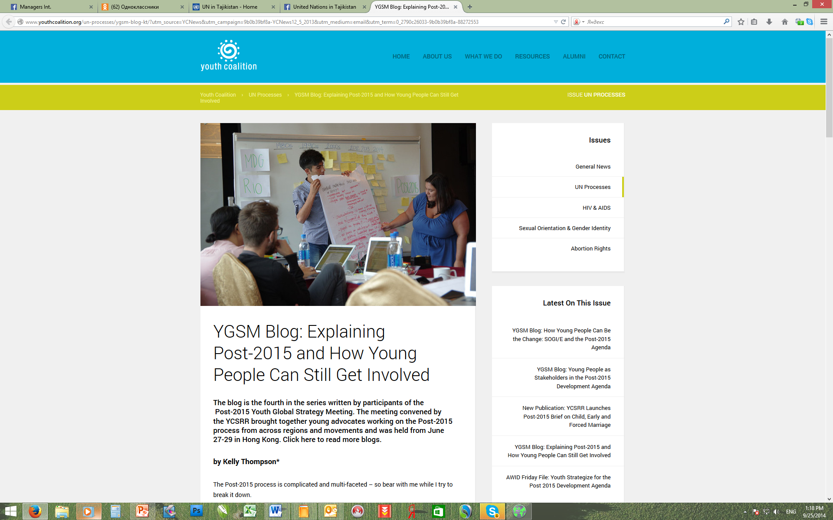Press-release devoted to the second round of national consultations was drafted and disseminated among local, regional and international mass media, partners and stakeholders representing the governmental, international and public entities. The press-release was developed in three languages (Tajik, English, Russian) and was posted on UN web-site and relevant social media channels.

In the center: Mr. Sharaf Boborakhimov, Y-PEER Representative from Tajikistan at the Post MDGs Youth Global Strategy Meeting.

As a result of the second round of national consultations, feature story with interviews from different participants was prepared and to be published in the next issue of the UN bulletin.

Information and advocacy work was done simultaneously by young people – volunteers of the UN agencies in Tajikistan, mainly, Y-PEER Tajikistan Network members. For active participation in promoting the ideas of Post MDGs and ICPD 20 agenda, one of the Y-PEER Network representatives from Tajikistan was invited to partake at the Global Post-2015 Youth Global Strategy Meeting took place in Hong Kong, China by YouthCoalition, the global youth platform. Tajikistan representative was the only from the region and became a part of a team of 21 young leaders from across the globe.

Links to the external and internal sources related to the second round of the Post MDGs consultations in Tajikistan:

<https://www.facebook.com/media/set/?set=a.780091062042680.1073741837.272610259457432&type=1>

<http://www.youthcoalition.org/un-processes/ygsm-blog-kt/?utm_source=YCNews&utm_campaign=9b0b39bf8a-YCNews12_5_2013&utm_medium=email&utm_term=0_2790c26033-9b0b39bf8a-88272553>

<http://untj.net/index.php?option=com_content&view=article&id=1013%3A2015&catid=187%3Anews-worl-we-want&Itemid=820>

<http://untj.net/files/Talk/2015-Press-release-Tj.doc>

**Stakeholder Mapping**

A first step towards implementing any prospective goals or targets is to identify the key stakeholders at the local levels, their roles, responsibilities and capacities.

To this aim, participants were asked to brainstorm on a stakeholder mapping. They were asked: Who, at the local and national levels, are the stakeholders that can help implement the development agenda and what are their strengths and weaknesses? Their answers showed that while the main responsibility was that of the government, other stakeholders also had important roles and contributions they could make.

|  |  |  |  |  |
| --- | --- | --- | --- | --- |
| **Cluster** | **Stakeholder** | **Role and Responsibility** | **Strengths** | **Weaknesses** |
| Civil society | Populations | * Participation in the identification of priorities and goals. * Participation in the design and implementation of strategies * Ownership and support * Contribution through their human/labor resources | * Deep knowledge and concern about their situation. * Ability to organize and mobilize. * Experience * Collective support “Hashar” * Social capital * Motivation/desire to work * Literacy * Drive and ambition | * Lack of responsibility * Lack of awareness/information * Low levels of knowledge and capability * Lack of initiatives * Lack of collective organization. * Indifference * Lack of oversight. |
| Community based organizations | * Mobilization of communities * Protection of rights and interests of groups | * Mobility * Closeness to people * Knowledge * Experience * Initiative * Goodwill * Innovation * Practical help * Consultative and participatory approach | * Lack of sustainability * Lack of resources * Lack of precise strategy, action plan etc. * Weak cooperation between them * Weak relations and contacts * Lack of real power * Sometimes, lack of adequate representation. |
| Media | * Awareness raising * Education role * Advertising | * Public attention * Ability to reach public * Expertise * Influence | * Lack of adequate widespread coverage and reach * Low quality programming * Lack of contemporary programming * Lack of resources * Weakness of journalism as profession * Lack of adequate coverage of real problems * Dependency on donor/financing bodies |
| Government | National government | * Administration * Investment, budgeting * Monitoring * Approval of plans and execution | * Power to execute * Ability to approve policies * Centrality * Experience * Resources * Knowledge and access to information | * Weak monitoring * Lack of adequate resources * Lack of specialists and thematic experts * Inadequate innovation, such as e-governance |
| Parliament and councils at the local level | * Elaboration and adoption of laws * Ensuring checks and balances * Approving strategies, plans and budget | * Independence * Ability to draft laws * Representation of people * Sectorial expertise * Experience | * Weak results from execution of laws * Distance from constituencies * Weak participation in adoption of policies * Lack of full independence of some MPs. * Weak imitative |
| Executive bodies at the local level (local government, and self government bodies) | * Adoption of relevant policies * Enforcement * Implementation of plans Adoption of relevant * Monitoring, evaluation and accountability | * Experience * Local knowledge * Influence at the local level * Ability to inform central government of local realities and help shape regional policies * Cooperation with civil society | * Lack of labor force and units. * Lack of adequate cadres * Lack of resources * Lack of accountability towards policies not implemented * Lack of responsibility towards execution of policies * Inability to take people’s problems into account. |
| Private sector | Private businesses and businessmen | * Investment * Incentives for participation * Service provision * Implementation of plans | * Resources and assets * Ability to create jobs * Credit * Contribution to economic growth * Payment of taxes | * Lack or low knowledge about development plans and their means of implementation. * Primary interest in benefits and incomes * Lack of incentives for participation. * Personal interests |
| **International organizations** |  | * Funding support * Education and awareness raising * Sharing of information, experiences and best practices from other regions/countries * Partnership * Encouragement and support | * Grant giving * Sound monitoring and demand for accountability * Experiences with new initiatives and innovations * Clear guidelines and objectives * Cooperation with the government * Knowledge * Ability to involve civil society in programs and plans * Operating within the framework of laws and regulations of the host country. | * Low levels of funding * Conditionality for funding and support * Lack of human resources * Protection of own interests * Temporary solutions and lack of sustainability of presence * Weak cooperation with local governments |

**Defining local bottlenecks and opportunities for implementing the post-2015 development agenda and new NDS**

Once stakeholders have been identified, the main bottlenecks need to be acknowledged together with means to overcome them

Participants were asked to draw five main problems in implementing the post 2015 Development Agenda and the new NDS and propose for each of the problems raised a specific solution. The problems were then clustered thematically.

It transpired from their answers that the main blocks of problems were related to perceptions about lack of resources, capacity, administrative skills and information. These happen to be the major obstacles to proper implementation of development goals, not only in Tajikistan, but also at the global level.

|  |  |  |
| --- | --- | --- |
| **Resources** | | |
| **Problems** | **Possible solutions** | |
| * Lack of resources for adequate financing of plans and strategies. | * Identification of sources of financing at the local level. * Enabling and providing incentives for the growth of private sector * Ensuring more participation by the private sector in the design and implementation of strategies and plans. * Active investment into attracting external (domestic and foreign) investors. * Ensuring meaningful participation, ownership and investment (both in kind and in cash) of stakeholders in the planning and execution of plans, strategies etc. * Ensuring incentives and benefits for attracting resources and investment from different stakeholders. | |
| * Incorrect or inefficient utilization of financial resources and of the local government budget. | * Searching additional funds * Better streamlining and improving the efficiency of expenditures at the local level * Attraction of investments. | |
| * Low income for government officials hence low incentives. | * Drawing investments into the creation of job and raising of salaries. | |
| **Capacity** | | |
| **Problems** | **Possible solutions** | |
| * Lack of appropriate education, hence capacity, for management and implementation of development projects | * Strengthening public administration through training, investment in higher education, grants, development of university curricula etc. * Enabling government officials to upgrade their skills through periodic training and short courses. * Organization of short courses, internships, study trips to upgrade skills and knowledge, especially for officials working at the local level. * Leaning from experiences of other countries for officials responsible for designing programs and strategies. | |
| * Lack of professional and thematic expertise at the local (sub-national) level. | * Enhancing expertise and skills through organizing specialised trainings, seminars, short courses etc. * Sponsoring of skilled workers through education courses in and outside the country. * Regular training of cadres. * Ensuring the systematic inclusion of women in consultation workshops. | |
| * Low qualification of young experts. | * Focus of education and training for young specialists. * Development of incentives to draw in young specialists in public administration. | |
| **Administration/Governance** | | |
| **Problems** | | **Possible solutions** |
| * Lack of interest and involvement of civil society at the local level. | | * Involving civil society in the design, implementation, monitoring and evaluation of development projects. * Organization of joint projects with civil society * Identification and dedication of specific roles for civil society during planning and implementation of projects. |
| * Failure to draw lessons through identifying a proper monitoring system in the design and implementation of development strategies and plans. | | * Conducting regular monitoring and evaluation during implementation and adjusting projects according to results found. |
| * Low priority to coordination between programs at the national and local level. | | * National level leadership to show commitment to regular two-way dialogue with local government representatives. * Improving coordination between needs and programs at the national and sub-national (Local) levels. * Consultation with civil society and the private sector in order to design programs relevant to local needs. |
| * Failure to take into account the interests of stakeholders in the design and implementation of strategies and plans. | | * Assessment and analysis of problems at the local level * Ensuring a consultative process at all stages with stakeholders: design, implementation and monitoring. |
| * Inadequate collection of taxes based on the specificity of each district or location. | | * Introducing reforms in the Tax Codes. |
| **Information/Awareness** | | |
| **Problems** | | **Possible solutions** |
| * Lack of sufficient information concerning goals and priorities. | | * Design and implementation of information and awareness raising campaigns on the goals, priorities, strategies and plans especially at the local level. * Engaging the media in information campaigns (commissioning articles, ads, editorials etc.) |
| * Low level of qualification and education of citizens in villages. | | * Organization of meetings with collectives at the regional (sub-national) levels and in rural areas. * Regular organization of consultative workshops at the local level. * Targeting rural populations for special education in different development-related subjects/themes. |

Six themes stood out as the principle means of implementing the development goals, be they at the global, national, or local levels. These were:

1. Ownership
2. Participation
3. Partnership
4. Capacity
5. Planning and Budgeting
6. Monitoring and Evaluation

**Ownership (Localization of the Development Agenda)**

*Why?*

Ownership means, in practical terms, to make one’s own. If there is sufficient investment in the design of a project, then that the sense of ownership and commitment increases. By the same token, if there is no feeling of ownership, there is no commitment to ensuring that development plans and strategies are implemented fully.

*How can ownership be ensured, encouraged and improved?*

When it comes to the Global MDGs or the Post-Development Agenda and its eventual new goals and targets, the question is raised as to how people at the local level can “own” global goals?

Participants noted that holding such consultations in different countries during the design of the Post-2015 Development Agenda in principle open the possibility for people at the local and national levels to have an input into the identification of global goals. Yet, more realistic and appropriate for local level representatives is to have ownership over goals at the national level.

As to how ownership can be ensured at the local level, participants stressed on the ability to have input into the design and implementation of strategies. Specifically, they identified a number of prerequisites and steps that would ensure that the process leads to a sense of ownership by stakeholders:

✔ Trust between civil society actors, local government and national government officials. This trust requires accountability and transparency at all stages.

|  |
| --- |
| *50 Year old male, member of the civil society:*  *In order to localize the global goals in Tajikistan, civil society plays a key role. Without their active participation, no plan can be truly and adequately implemented in the country. This requires further investment in developing civil society in Tajikistan. Unless there is trust of people, no plan can be truly implemented at the local level. It is therefore important for the local governments to encourage trust of people in their plans.* |

✔ Sufficient awareness by stakeholders at the local level about the goals under consideration and the process of choosing priorities. Knowledge about goal setting agenda at the global level.

✔ Developing sufficient capacity of stakeholders (including civil society, self-governing bodies and local governments) so that they could commit to the plans.

✔ Participation of all stakeholders, especially civil society in the identification of priorities, goals and targets at the local level. Sustainable and systematic participation should be ensured, participants noted, through for example the creation of Consultative Councils within government structures with the presence of civil society organizations.

✔ Prioritization of goals and development of strategies and plan on the basis of local realities, taking into consideration local needs, capacities, resources and aspiration.

|  |
| --- |
| *30 year old woman, staff of an international organization:*  *In order to localize the Global Post-2015 Development Agenda it is first of all necessary to adapt these global goals to local conditions, and then integrate them into the planning process at the national level.* |

✔   In a consultative way, engaging in the process of planning, namely:

* Development of a Strategy
* Identification of a precise Action Plan, Work Plan
* Identification of responsible bodies and responsibilities
* Allocation of sufficient budget and resources

✔ Decentralization of administration and resources. Adequate use of human resources at the local level.

|  |
| --- |
| *35 year old local government worker:*  *First of all, it is necessary to identify the goals from the ground up, at the local level, and then identify the resources needed and available. For true ownership at the local level, the administration of plans and resources should be delegated more to the local level. To implement an adequate tax system at the local level.* |

✔ Ensuring a feedback mechanism whereby feedback is provided on the assessment, design and implementation of plans from bottom to top as well as from top to bottom.

✔ Ensuring the appropriate mechanisms for consultation and feedback thought out the process, including implementation and monitoring, for example through consultative councils.

|  |
| --- |
| *50 Year old male, member of the civil society:*  *At the moment; there are some councils created within government structures but they are not open to the participation of representatives of civil society. We propose the creation of consultative bodies with 50+1% participation of civil society organizations.* |

**Participation of Stakeholders at the local and national levels**

*why?*

To participants of the consultations, the meaning and virtues of participation was clear. If stakeholders do not participant in the design and implementation of development agendas, chances are that they will not commit to their success at best, or, in the worse case, they could even hamper the full implementation of goals.

*How?*

In terms of how participation can be ensured, participants mentioned existing mechanisms (such as consultative bodies, parent teacher associations, civil society platforms) etc., but also the need to create new platforms and consultation councils.

*Challenges*

Yet, participation, while desirable, is not without its challenges and difficulties, especially at the local level. These include, according to the consultations held:

* Lack of information by local populations about the development plans, be they at the local, national or global levels. In other words, local governments do not adequately inform local populations of the strategies and goals.
* Lack of capacity for participation
* Lack of trust between local government officials, civil society and private sector.
* Lack of experiences in joint design and implementation of plans.
* Lack of meaningful and sustainable mechanisms.
* Lack of participation especially by women in some localities, namely in the mountainous areas where the education level of girls is decreasing.

|  |
| --- |
| *A 60 year old female civil society leader:*  *At the moment, development plans for local levels are being designed and planned from the top by the central government, without the participation of representatives of populations at the local levels. Yet, it is the local populations that best understand the problems and needs at the local level. It is necessary to design and implement plans from the bottom up, with the participation of people representing all walks of life at the local level.* |

|  |
| --- |
| *A 25 year old male youth activist:*  *For the moment, the youth are not at all consulted by local authorities or encouraged to participate in the elaboration of development plans at the local level. The youth need to be made involved in the design, implementation and monitoring of programs.* |

*What solutions to ensure more meaningful participation?*

Local and national governments have a responsibility to create a favourable environment for meaning participation by other stakeholders. Mechanisms could include:

* Creating incentives for participation.
* Sharing information and raising awareness.
* Providing resources and investing in participation. For example, local governments could provide resources for youth and women groups to organize seminars and consultations and then provide feedback , or invest in specific trainings to raise the capacity for participation.
* Ensuring the adequate legislative framework and policies that facilitate – and not hamper- participation.
* Encouraging women and the youth to participate in design, implementation and monitoring of strategies and plans.
* While designing plans and strategies at the local level, a Working Group should be created with the inclusion of representatives of communities, civil society, independent experts, specialists, influential and experienced personalities etc.

But civil society also has responsibility to seek ways to participate in the design and implementation of development plans. After all, they have stakes in their success as citizens and representatives of local communities. These responsibilities include

* Actively seeking information.
* Being active and caring for outcomes.
* Investing own resources, be they in kind (human resources) or in monetary forms.
* Improving their legal education.
* Getting involved in monitoring and evaluation and seeking accountably from public officials.
* Ensuring that women and the youth play a key role in participation in implementation of plans.
* Encouraging their experts and specialists to become involved in sectoral planning.

|  |
| --- |
| *45 year old female civil society member:*  *For the moment, relations between local governments and civil society groups is not optimal. Efforts are needed from both sides in order to break down obstacles to consultation, participation and feedback. Efforts needed may include dedicated resources, transparency, improved communication, and investments into raising the legal education of local populations.* |

**Partnership between stakeholders**

*Why?*

Partnership induces cooperation between stakeholders, which by itself is a key asset in the implementation of development agendas. Partnership is a necessary component of success, because, after all, the government at the local or national level is not the only actor with roles and responsibilities. It needs the support and contribution of other stakeholders.

*How?*

Participants of the consultation outlined a number of preconditions for the principle of partnership to be implemented successfully. These include:

* Trust between partners
* Cooperation and division of labor based on strengths and opportunities
* Equality
* Transparency

Partnership could be between different groups at different levels, starting at the village level, Jamoats, regions, cities, provinces and at the national level. Partnership should be among village councils (JAMOAT), local councils, civil society, private sector, and local government executive bodies.

*Challenges*

Partnerships require work. In the conditions of Tajikistan today, participants noted the many challenges that hamper effective collaboration, namely:

* Lack of previous successful experiences when local governments, private sector and civil society partnered together on joint projects.
* Lack of equality between partners: the Government at the national and local levels is decidedly more powerful in terms of resources at its disposal, responsibility, ability to draw policies and laws etc.. Yet, if there is no partnership in implementation, the policies will not be able to reach people and could stay on paper only.
* Lack of a sense of responsibility towards shared goals and outcomes.
* Another challenge is the low level of education – especially civic education – of people across the board, be it in the government, in organizations or in companies. This lack of civic education and knowledge translates in people competing rather than investing in mutual cooperation and partnership.

|  |
| --- |
| *A 38 year old representative of a local government executive body:*  *The principle problems that hamper partnerships are related to personality issues and lack of professionalism: Lack of belief in the outcome of activities, lack of feeling of responsibility by responsible parties and personalities, bad choice of cadres and lack of professionalism among them. To encourage partnership, authorities need to reward personal initiatives to share and reach out.* |

*How can partnership be enhanced?*

Among ways that partnership can be encouraged and enhanced towards the goal of cooperation in the implementation of development agendas, participants shared the following possible strategies, all of which boil down to instigating concrete mechanisms:

* First of all, a culture of partnership is necessary, which could be enhanced through education, raising awareness about the benefits of partnership, examining the examples of other countries, etc..
* Removal of barriers. A first way to ensure partnership is for local government officials to remove red tape and barriers to cooperation that could exist and instead think up of concrete mechanisms, policies and even laws that would encourage partnership.
* Sustained dialogue. The more formal and informal opportunities there for local government representatives to engage civil society and the private sector, the more chances there is that they could partner up for implementation.
* Specific incentives are necessary to draw in partners. For example, participants noted that funding, joint monitoring, ensuring that feedback is taken into consideration etc. could be constituted in order to motivate and encourage partnership.
* Another mechanism is for non-government representatives to feel responsibility and ownership enough in the development agenda so as to invest and make efforts to become engaged as a partner in the plans being designed at the local and national levels.
* Personal benefits and ambitions should not come in the way of seeking partnership with others. Leaders and influential personalities, be they in the government or among civil society, need to provide incentives by setting good examples.

|  |
| --- |
| *30 year old Female lawyer:*  *The government should organize roundtables, brining together stakeholders, in order to identify each group’s assets, opportunities and needs in order to strengthen partnership. Officials need to be specifically trained to organize such round tables and learn from the experiences of other countries.* |

*In which areas should partnership be specifically strengthened?*

* Joint monitoring and evaluation.
* Joint project implementation in different sectors and among communities Joint decision on allocation of resources to priority sector and projects.
* Sharing financial investments and contributions. Participants stressed that while a large number of development projects today are being funded by international organizations and donors in Tajikistan, it is necessary to attracting more funding from domestic sources, including from the private sector.

|  |
| --- |
| *A 52 year old male head of Economic Department of the provincial government:*  *Whenever a project, policy or law is being designed, the government should clarify the share of the budget allocated to it so that at the same time, additional fund raising could be conducted from other domestic, private sources and external donors.* |

**Capacities**

*Why?*

Perhaps the most important means of implementing the Post-2015 Development Agenda at the local level, other than political will, is the adequate capacity to do so. Without capacity, plans stay on paper or on drawing boards at best. Or, in worse cases, the implementation falls short of desired outcomes and gets deviated into inefficient paths.

*Which capacities?*

To participants of the national consultations, capacity is not only knowledge about technical matters, or the existence of infrastructure, but also about education and awareness in general and skills in good management and public administration. They lamented that capacity is very low in Tajikistan in general, related to the low quality of education, a problem which had been chosen in previous consultations as the first priority for the post-2015 Development Agenda relevant for the country.

*Challenges*

* An important challenge for Tajikistan, especially at the local level, is the low quality of specialized education.
* Another challenge identified by participants is the lack of technical capacities, i.e. infrastructure for implementation (such as roads, communication lines, etc.), and including social infrastructure (adequate hospitals, schools etc.). These are even more acute at the local level and in rural areas, especially in the mountainous regions.
* Overall, lack of capacity is related to lack of awareness and understanding, and not only education.

|  |
| --- |
| *40 year old male local government official:*  *The insufficient number of personnel within the local government bodies, and the amount of tasks affects the quality of work produced.* |

*How can capacities be improved?*

Participants stressed that government officials have the prerogative to seek the enhancement of capacities for a more efficient management of policies and plans, but people themselves, be they officials of public administration, civil society representatives, community members, business people etc. all have the responsibilities to work on improving their own capacity. This would include better usage of existing opportunities but also developing new ones, such as, for example, the following measures:

* Investing and allocating more budget to strengthening the education system. Some participants argued that instead of rising the number and quantity of weak universities and special education institutions, the government should invest in the quality of a few of them.
* Public administration and management require specific skills which need to be enhanced through the creation of special schools, curriculum, or study abroad.
* Organizing regular training and skills enhancement workshop for government workers at the local and national levels.
* Sponsoring research and assessment of existing capacities, opportunities and weaknesses in the different sectors of the priorities of the NDS and the Post 2015 Development Agenda, and developing specific programs to target the gaps. Similarly, conducting an assessment of capacity needs at the local level and designing specific programs.
* Dissemination of information, pamphlets, education materials about the development challenges, goals, priorities of Tajikistan and of the global arena.
* Sharing of experiences and twining of government officials from different localities in order for them to learn from each other.
* Encouraging the private sector to invest in training, education system, skills building courses etc..
* Investing in introducing new technologies and new infrastructures, especially at the local level and in rural areas.

|  |
| --- |
| *A 30 year old representative of a local government:*  *At the local level, public administration is rather weak. One way that it can improve is to expand e-governance. Like this information can be made easily available to stakeholders and duties and responsibilities identified for a better distribution of tasks.* |

**Planning and Budgeting**

*Why?*

It is obvious that means of implementation of development goals go through proper planning and budgeting both at the national and local levels. Since participants of the sub-national workshop organized in Tajikistan represented mostly the economic departments of local governments, they were well versed and skilled in questions of planning and dwelled long into its technical intricacies.

As the representative of a major provincial government put it planning and budgeting are both the principle tools for administration and the main indicators for progress and development at the local level.

*How can planning and be budgeting be enhanced?*

A number of important messages came out of the consultation regarding the planning process in Tajikistan and how it can improve for implementing future national development strategies and plans or goals, be they at the local or national levels:

1. The first step is to conduct an assessment of the needs of the region/locality, and then develop long term visions in a participatory way and to identify priorities. Afterwards medium term planning can take place and adequate budget allocated to priorities in a transparent way.
2. Planning and budgeting should not be two distinct and unrelated exercise, as they seem to be at the moment, but correlated tightly. Long term goals provide the strategic direction, plans identify the steps and the budget should then be allocated accordingly. Often, planning and resource distribution is not conducted according to strategic visions and needs but existing budget and expenditures.
3. The budget should not only consist of cash resources and expenditures, but also in-kind contributions, such as for example social capital of a community, human resources, potential investments by the private sector etc.
4. Government at the local and national level should take sustained and concrete steps towards attracting the private sector to invest in development projects. Strategies to encourage the private sector could include:
   1. Improving the legal and policy framework and reducing the red tape (bureaucracy)
   2. Sharing information and raising awareness about plans and goals and the process of planning among businessmen.
   3. Organization of workshops and roundtables.
   4. Incentives such as tax breaks, low interest credit, infrastructure allocation etc.
   5. Wide dissemination of results and outcomes of development projects and how they improve the well being of stakeholders, communities etc..
5. Planning and budgeting are participatory exercises. It is important for all stakeholders to be involved from the beginning.

|  |
| --- |
| *44 year old head of Economic Unit of a provincial government (ВМКБ):*  *Ensuring transparency in the preparation and implementation of local government budgets can considerably improve the planning process* |

1. As representatives of the local government, much like community based organizations, are closer to people and issues at the local level, they should be made more responsible in planning and budgeting. This means that planning for the implementation of development goals should be a bottom up exercise and that further decentralization and devolution is necessary in order to empower local governments, including through the introduction of an effective taxation and budgeting system at the local levels. Some participants argued that profits from local companies for example should go directly into the local budget where the companies are located and not the central one.

|  |
| --- |
| *43 year old male economist, head of Economic Unit of the capital:*  *Identification of sources of financing is the most important mean for implementation. Giving independence to the budget of local governments can improve the planning and budgeting process considerably at the local level.* |

1. At the same time, participants argued that monitoring of the budget and plans, as well as setting up of strategic national goals and priorities should remain as the prerogative of central government.
2. In planning for the future, existing plans and strategies should be assessed in order to draw lessons for addressing the gaps and shortages.
3. Good plans should also include indicators for monitoring, benchmarking etc.
4. In order to improve the efficiency of the process, the relevant cadres of local governments should be sufficiently trained and their knowledge constantly upgraded. Working groups should also be set up within local governments between different sectoral groups.

**Monitoring and Evaluation**

*A challenging notion*

Before turning to the virtues of a Monitoring and Evaluation (M&E) system in the implementation of development agenda, participants discussed what such a system entailed and what different types it could encompass. This because as it became clear through discussions, at the local level M&E had different meanings. Because of the lack of understanding of people and communities of what monitoring is and how they can use it to their advantage, it was deemed difficult to implement a proper M&E system at the local level with current conditions. To this was compounded the lack of properly trained personnel, communication technologies, technical and financial base. That is why they believed that an adequate system was not being implemented especially at the local level.

|  |
| --- |
| *43 year old male representative of local authorities:*  *The role of monitoring and evaluation is considered of great importance. In the absence of such a system, the sense of responsibility between government structures can decrease sharply.* |

|  |
| --- |
| *50 year old female representative of civil society:*  *Monitoring should not be understood as a scrutinizing tool for singling out culprits and punishing them but as a system to recognize problems at an early stage, draw lessons and searching improvement for future plans* |

*Why?*

Despite this challenge, participants stressed the important role of M&Es in localizing national priorities and in the planning process throughout the different sessions. They saw the M&E exercise as a tool for:

* Measuring progress and assessing the real situation at the local levels.
* Cooperation with stakeholders, especially with civil society at the local level.
* Planning, as indicators allow for an assessment of where society is and where it wants to reach and by when, within which time framework.
* Improving data: M&E as a tool requires investment into the improvement of data collection and data analysis.
* Allowing for a systemic accountability of progress towards goals.
* Making revisions to future plans based on assessment of existing ones.

*What would be the best way to monitor and evaluate the delivery of goals at the local level?*

First of all, local communities, civil society and even local level officials need to be made aware of what M&E system and participatory monitoring is and how it can be used properly to ensure accountability. For this, a series of specialized trainings are necessary.

For M&E systems to be effective, participants argued that a number of pre-requisites are necessary. They include:

* The existence of reliable data and steps towards improving them.
* Correct identification indicators to monitor and adequate survey methods. This could include the use of new technologies.
* Correlation of indicators with the statistics of sectoral ministries and structures.
* Continuity of the exercise in regular intervals. M&E is not a one time exercise.
* Involvement of local communities in a participatory approach to evaluation of projects and taking their recommendations into consideration.
* Involvement of local experts in the evaluation and assessments.
* Regular training for local government officials.
* Proper planning for the correct utilization of the results of evaluations.
* Timely relating of results to stakeholders and planners.
* Ensuring transparency in the M&E system.
* Taking gender considerations into special consideration.

Specific recommendations were provided to different groups:

Civil society actors;

* More active participation.
* Inclusion of impartial professional experts in the process.
* Strengthening cooperation with different stakeholders.

Local and national government structures

* Coordination
* Refraining from blocking
* Creation of conducive environment.
* Gathering correct indicators.
* Involving experts.
* Organization of trainings.
* Organization of M&E groups from among communities, the press etc.
* Creation of an Advisory Committee on M&Es with the participation of local government and national government representatives within the Ministry of Economic Development and Trade.

Research institutes

* Development of guidelines for M&E
* Organization of trainings and expert level education for representatives of local and national government.
* Overall monitoring.
* Analysis from policy perspective and preparation of recommendations.
* Learning from other experiences.
* The use of the press.
* Establishment of a research Center.

**Conclusion**

The two day consultation brought many new ideas on how development goals can be better localized, or in other words, implemented at the local level. The discussions highlighted a few grand themes that seemed to be recurrent in the context of Tajikistan today.

These cross cutting themes and priories highlighted in the majority of the groups sum up the main challenges for the implementing the Post-2015 Development Agenda in Tajikistan as well as future National Development Strategies. They include:

1. Emphasis on the need for good governance, including
   * Instigating a  sound system and structure of governance both at local and national levels
   * Cubing corruption
   * Increasing consultations and the involvement of people in decision making processes, through, for example, creating new consultative bodies (Shuroi mashvarati)
   * Improving access to services and the quality of the services
   * Ensuring transparency and accountability
2. Allocation of sufficient resources, through better rationalization of existing funds and budgets, seeking grants and investments by the private sector, and better usage of human capital.
3. Ensuring adequate legislation and an enabling policy environment through:
   * Opening up the policy making system to more participatory approaches.
   * Improving mechanisms for the implementation of laws and policies;
   * Instigating a proper monitoring system of the implementation stage.
4. Raising capacity of the work force and of experts, through:
   * Instigating systems to enhance capacities through incentives for knowledge seeking.
   * Investing proper resources to skills building.
   * Insisting on knowledge and skills for the labor force through a system of meritocracy

5)      Finally, what came out strongly in the consultations was the need to enhance informal institutions. In the context of Tajikistan today, this meant building on certain intangible goods that held society together, things like:

* + Trust
  + Values
  + Social capital of communities
  + National traditions

These values could only enhance the ability of the country to move forward with national unity and encouragement to face the future post-2015 development agenda.