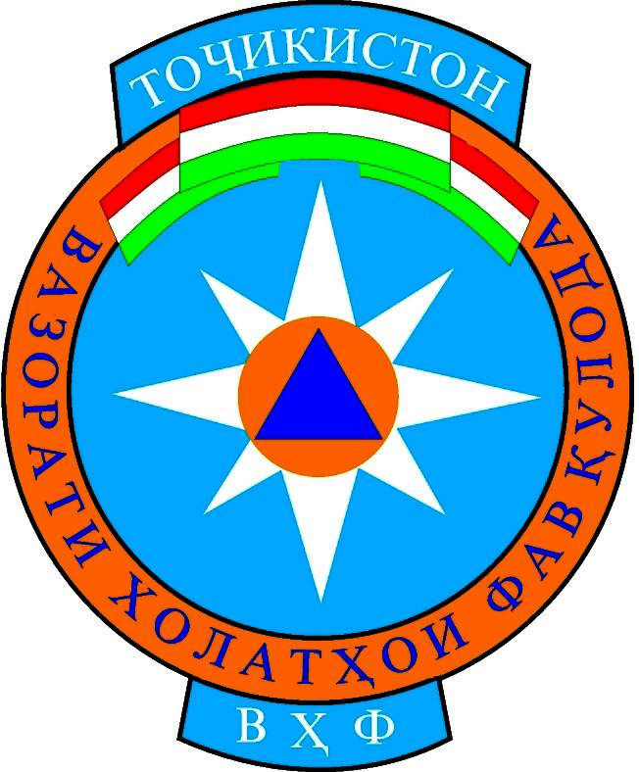
Garm, 9 February, 2006 Ref/ No: ML/194
To: Dushanbe: UNDP, GAA, DIPECHO, RCST
Garm: MES regional representative, GAA, ACTED, Mercy Corps, MSDSP, OSCE,
PSF, WFP, UNDP, Hukumat, RCST, CDH
Rasht Valley: MES district representative

REACT Meeting Minutes of Rasht Valley
31.01.2006. 10.00 – 12.00 pm

Venue: Merlin Office, Rasht Valley

Chairman: Dilovarsho Nodirov, Program Assistant of OSCE. Rast Valley

Participants: 15 people (the list of participants are attended the meeting will be submitted on annex).

Agenda:

- Acceptance of the present agenda and minutes from the previous REACT meeting.

- Discussion of the Training Center of MoES Rasht Valley and its functions and use.

- Status of preparedness of REACT partners for winter 2006/Preparedness Plan for Rasht Valley.

- Any Other Business.

The chairmen of the meeting opened the current meeting and submitted agenda of the meeting to the participants.

About the first agenda of the meeting discussing were begun and the participators conceded acceptable first agenda.

Then about the second point of the meeting debating was start and due to the absence of colonel Usmanov. M, the Head of Regional Branch of MoES of Rasht Valley the participators came to final conclusion that to put this issue to the next REACT Meeting. . As UN asked to postpone this point to the text REACT meeting because REACT members can not discus Training Center of MoES Rasht Valley in his absence.

Then the participators of the meeting began to discussing of the third point that it was about the “Status of preparedness of REACT partners for winter 2006/Preparedness Plan for Rasht Valley”.
In the first, captain Shafiev Vanjali- the Officer of Regional Branch of MoES explained to the participators the current whether situation of Rasht Valley. He stated that:

- In Jergatol District the roads are blocked with snow and there will be risk of avalanches.

- In Nurobod District in Jari Kabud place the situation is hard and particularly in 108-112 km of the main road there is an avalanche.

- In Rasht District there is much snowing that it affected to population. For example in 27th of January in result of much snowing the roof of high school #67 in Navdonak village was totally collapsed down and during this disaster about 13 cubic meters of timbers and 300 roofing tiles were broken. The above mention school had 8 classrooms and about 300 pupils were studying in this school.
- And also in village of Dashti Rasht in Rasht District in result of avalanche the drinking water pipe from this village was under avalanche. Also the roads are blocked to other places from the centre of the district.
- In Tojikobod District the drinking water is damaged.

- In Tavildara District the roads are blocked by snow.

Jamila Zaripova Merlin Program Manager asked from MoES representative that last year there was such condition in Rasht valley and do you have any preparedness in this year or do the government assisted to MoES and CD for the preparedness for the Natural Disasters in this year?

Captain Sharipov answered that up to now the government of republic facing to some difficulties in economy and the MoES it’s a new ministry and there is no opportunity to allocate budget to Emergency Preparedness in advance. But there is allocate budget partly and it’s only for Emergency Situation and during Emergency Situation it will be used. But in current time, due to some above mention issues we are require from NGO for assisting to Rasht MoES. We are kindly asking you that you discuss these issues with your donors and senior staff and support us. And we mentioned before that during emergency situation due lack of techniques and petrol we can not to run our support to community during natural disasters and emergency situation. We are kindly asking you to support us with petrol and oil that we could assist to the community in needed time

According to it Parviz Bozorov, representative from GAA stated that the donors can assist only during natural disasters and emergency situation but only when they receive request letter from responsible organization and local governments and then they will run there activities to community.

Lieutenant Giyosov- Head of Rasht District MoES Branch highlighted that all Rasht district Branches are ready and have preparedness to natural disasters but we are facing to difficulties in patrol and oil.

Parviz Bozorov, added that those budgets that allocated for natural disasters for NGOs it will be distribute with close collaborating with local governments and district branches.

Hasanjon Turaev, representative from MSDSP highlighted that just there is no agreement in some issues among district branches of Rasht Valley and for the sake of it we prefer to collaborate with districts local governments in each Rasht Valley Districts. He added that just MSDSP, Rasht Valley sand a letter to there seniors staff and request for the assisting to community in this emergency situation.
At the end of the meeting the participators discussed the next meeting agenda that it will be:

- Discussion of the Training Center of MoES Rasht Valley and its functions and use.
- Activities for prevention of disaster that has epidemiology characters. (Turkish infestation pest or yellow Turkish moth).
- Any other business.

With the agreement of all the participants the next REACT meeting will be on 22nd February 2006, at 9:00 a.m.

The chairperson thanked the participants for a productive discussion and the meeting adjourned at 12.00a.m.

Participants of the REACT groups meeting of Rasht valley that the meeting was held in the 31 of January 2006 in the meeting room of Merlin Office, Rasht Valley.

Regional branch of MoES,
Rast valley:
- Lieutenant, Nozimov. S
- Shafiev Vanjali, Assistant of Head of Regional Branch of MoES Rasht. Valley

Rasht District MoES Branch:

- Lieutenant,Giyosov. Sh, Head of District Branch

Rogun District MoES Branch:

- Capitan Nurulloev. Sh . Head of District Branch

Merlin:

- Jamilya Zaripova, Project Manager
- Abdullo Mirzoev, Office Assistant
- Raano Sharipova, Project Trainer
- Kulmahmad Nurov, Doctor

GAA:

- Rustamov Bahrom, Field Officer
- Parviz Bazarov, Project Officer

OSCE:

- Nodirov Dilovar, Project Assistant

RCST:
- Sharifkhojaev ,Sh Reresentative

WFP:
- Bahromov. A Project Assistant

Mercy Corps:
- Nazarov. M Trancport Manager

ACTED:

- Hafizova. S Project Assistant

AKF/MSDSP:
- Turaev Hasanjon, Deputy regional Manager

UNDP:
- Shohmuzafar, Representative

