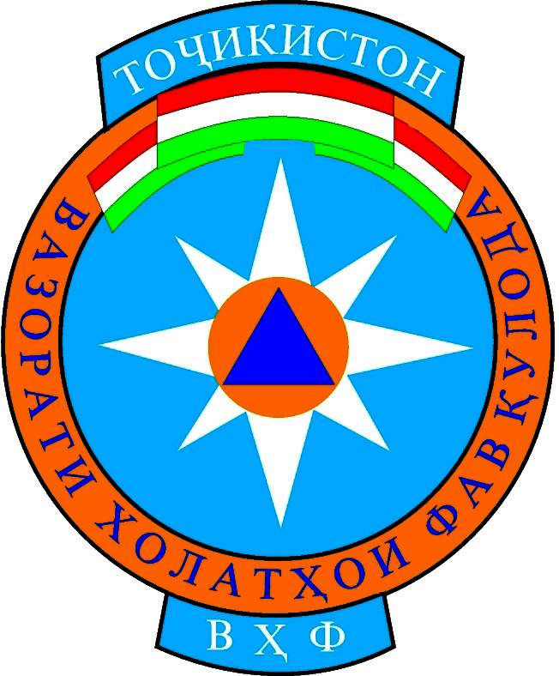

REACT Meeting Minutes of Rasht Valley
22.02.2006. 9.00 – 12.00 pm

Venue: Regional Branch of MS of Rasht Valley.

Chairperson: Jamilya Sharipova, Health Program Manager, Merlin, Rasht Valley

Participants: 22 people (the list of participants are attended the meeting will be submitted on annex).

Agenda of the meeting:

- Activities for prevention of disaster that have epidemiology characters. ( pest or Turkish brown tail moth).
- Any other business.

The meeting facilitator opened the current meeting and made a brief presentation about the first point of meeting agenda. She stated that wide spreading of brown tail moth is one of discussing issue and emergency of Rasht Valley. And she suggested from the meeting participators to express there views on above mentioned issue.

Zabirov N, - Agronomist of association of H\F, had brief information about Turkish brown tail moth. As he stated this is one of kind of moth that it not eliminated even in winter time. But during high cold temperature only 20% of this moth’s will eliminate.

Niyozov Z, The head of agricultural Department of Rasht Hukumat, highlighted that mainly the condition of the Rasht District is acceptable for horticulture and growing potatoes and it should be increased. Consequently, Rasht District Hukumat does not have possibilities in order to re-establish of gardens and fighting against the pest.

Mallaev K, the head of district chemical department, emphasized that for a defending of district horticulture from this kind of pest, AKF/MSDSP representative in Rasht Valley in close collaboration with local government provided 5,000 $ as a grant in Rasht District for fighting against of this kind of pest. And this activity showed a good result and affected about 90% to this kind of pest.

During the discussions regarding to this issue the REACT meeting team had an agreement that this issue will not find its solution only with supports of NGOs that based in Rasht. Fighting Turkish pest also requires constant cooperation with communities across the Rasht Valley. And there some kind of activities that requires a small budget.

The activities that suggested by REACT meeting participators against Turkish brown tail moth:

- On behalf of REACT members sand a request letter to head of districts hukumats of Rasht Valley regarding “Activities for prevention of disaster that has epidemiology characters. (Turkish brown tail moth ) and get permission for running this activity from 13 March 2006 till 19 March 2006 in six districts of Rasht Valley
- For implementation of “Activities for prevention of disaster that has epidemiology characters. (Turkish brown moth ), mostly should be involved local women because there is possibilities two kind of activities in Rasht Valley for prevention of this pest. These are mechanical and physical that it will not require hard physical work.
- With objection of prevention activities about this pest it will be require from WFP to provide food support for involving of local women in these activities.
- During implementation of this activity it should be distributed information booklets about of effecting and prevention of this pest among community of Rasht Valley. These information will be provide by AKF/MSDSP agricultural specialist and with a support of REACT members (Mercy Corps, OSCE, ACTED, WFP, GAA) will be printed and distribute to community.
- The responsibilities of providing report on “Activities for prevention of disaster that has epidemiology characters. (Turkish brown tail moth ) issue should be referred to district branches of MoES of Rasht Valley.
- After confirming of District Hukumats of Rasht Valley it will be sand a request letter to Government of Tajik Republic on supporting for prevention brown tail moth in Rasht Valley.

With these discussions the first point of meeting agenda was completed.

About others businesses of meeting, Muzafar Nodirov, - WFP Project Manager highlighted that in experience that it occurred in Jirgital and Tojikobod Districts, it has became defined that up to now the REACT members are not ready for Response during Emergency Situation yet. The assessment that conducted in Jirgital District, it will be one of examples. And this example showed by Mr. Nodirov to REACT members. He added that with agreement of all Rasht REACT partners, they should have one joint assessment during emergency situations. And it was offered that REACT joint assessment activities should be discuss once more. It was agreed that this issue will be discussed in next REACT meeting .

With the agreement of all the participants, the next REACT meeting will be held on 29th of March 2006, at 9:00 a.m – 12 a.m.

The agenda of the next REACT meeting:

- Rasht district branches reports on implementation of “Activities for prevention of disaster that has epidemiology characters. (Turkish brown tail moth )
- Joint Assessments of REACT members experiences
- Any Other Business.

The chairperson thanked the participants for a productive discussion and the meeting adjourned at 12.00a.m.

The list of REACT team participants

Regional branch of MoES,
Rast valley:
- Nozimov S,
Assistant of Head of Regional Branch of MoES Rasht Valley

Rasht District MoES Branch:
- Giyosov. Sh, Head of District Branch
Tojikobod District MoES Branch:
- Safarbekov A, Head of District Branch
Tavildara District MoES Branch:
- Barfiev B, Head of District Branch
Nurobod District MoES Branch:
- Saidov S , Head of District Branch
Merlin:
- Zaripova, J Project Manager
- Mirzoev, A Office Assistant

GAA:
- Rustamov B, Field Officer
- Rahmatov S, Agronomist
OSCE:

- Hafizov D, Project Assistant

WFP:
- Nodirov M, Project Manager
Mercy Corps:
- Tuliev Z, Administrator
ACTED:
- Nicolas Kroger Project Manager
- Hafizova. S Project Assistant

AKF/MSDSP:
- Juvonav S, Agronomist
Agricultural Department
of Rasht Hukumat
- Niyozov Z, Head of Department
District Veterinary
Labaratory:
- Sharipov A, Head of department
District Chemical
Department:
- Mallaev K, Head of Department
District Environment
Department:
- Ismoilov S, Head of Department
Jamoat Boki Rahimzoada
- Murodov F, Head of Jamoat
Association of Agronomists
- Zabirov N, Member of Association

